|  |
| --- |
|  |
| QF4102 Assignment Report |
|  |
| Financial Modeling |

**Prepared by: Meng Xiang**

2016-9-24

QF4102 Assignment Report

Financial Modeling

All scripts/codes can be found in the appendix and the rar file.

# Section 1

1. We just implement the formula given by

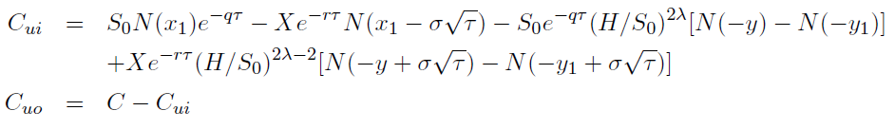

Please check the appendix or the code “Up_And_Out_Call.m” for the detail code. Note that we want the function to handle the case when S0 is a vector. This is for convenience of part (ii).

1. Based on the function Up_And_Out_Call (S0, X, r, T, sigma, q, H), we evaluated option value for different S0 and X=0.5, r=0.05, T=0.5,sigma=0.4, q=0, H=1.3:

|  |  |  |  |  |  |  |  |
| --- | --- | --- | --- | --- | --- | --- | --- |
| **S0** | 0.8 | 0.85 | 0.9 | 0.95 | 1.0 | 1.05 | 1.1 |
| **Value** | 0.2532 | 0.2669 | 0.2703 | 0.2628 | 0.2448 | 0.2175 | 0.1822 |

We further plotted the graph as follows:

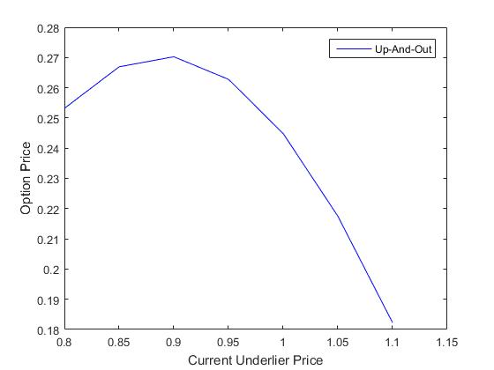

1. We used the code “BS_call.m” directly since we have done it as a tutorial question. Plot it versus different S0 in the same graph in part (ii), we get:

|  |  |  |  |  |  |  |  |
| --- | --- | --- | --- | --- | --- | --- | --- |
| **S0** | 0.8 | 0.85 | 0.9 | 0.95 | 1.0 | 1.05 | 1.1 |
| **Up-And-Out** | 0.2532 | 0.2669 | 0.2703 | 0.2628 | 0.2448 | 0.2175 | 0.1822 |
| **Vanilla** | 0.3309 | 0.3769 | 0.4237 | 0.4713 | 0.5194 | 0.5679 | 0.6167 |

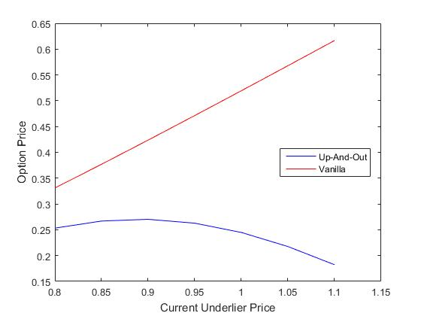

Firstly, we observe that the curve for vanilla call option is almost a straight line pointing upwards.That is, option price is higher if the current underlier price is greater. Intuitively, it is not hard to understand since high current underlier price implies a big chance for the future price to be high. Hence, the value for a call option is expected to be higher.

Secondly, the value of the up-and-out call firstly goes up and then falls down. We may consider it as a result of double effect of S0. At a lower level, similar to the reason above, the increase of S0 is beneficial. However, when S0 becomes greater, the increase of S0 can be a harm since it increases the risk for the terminal price to go out the barrier.

Lastly, we can see from the combined graph that value of up-and-out call is generally less than the value of vanilla call. It is a nature result because some of the profit that can be achieved in vanilla call option is blocked by rules of up-and-out option.

1. In this part, we coded the function for up-and-out option value with binomial tree method (BTM). The complete code is named as “btm_UOCall”. In order to plot the value versus different N, we use a script to calculate corresponding values. We also include the exact value using the function defined before. The following table and graph is obtained:

|  |  |  |  |  |  |  |  |
| --- | --- | --- | --- | --- | --- | --- | --- |
| **N** | 250 | 251 | 252 | 253 | 254 | 255 | 256 |
| **BTM Value** | 0.2509 | 0.2497 | 0.2498 | 0.2486 | 0.2488 | 0.2475 | 0.2477 |
|  |  |  |  |  |  |  |  |
| **N** | 257 | 258 | 259 | 260 | 261 | 262 | 263 |
| **BTM Value** | 0.2465 | 0.2466 | 0.2454 | 0.2456 | 0.2444 | 0.2616 | 0.2617 |
|  |  |  |  |  |  |  |  |
| **N** | 264 | 265 | 266 | 267 | 268 | 269 | 270 |
| **BTM Value** | 0.2605 | 0.2607 | 0.2595 | 0.2596 | 0.2584 | 0.2586 | 0.2574 |

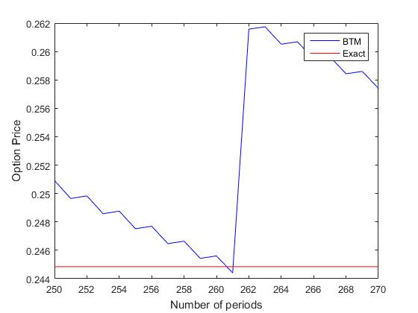

Generally, the BTM result is greater than the exact value. At the beginning, the value forms a ladder trending downwards. It dips below the exact value around N=261 and has a sudden increase.

1. We observe from the graph in part (iv) that N=261 gives the closet result, i.e., the least error. Based on the relationship :



We solved I by:

$$i=\ln\left(\frac{H}{S_{0}}\right)/(σ\sqrt{\frac{T}{N}})$$

and obtain the closet i=15.

# Section 2

1. For the newly issued option, we may just refer to the procedure taught in the lecture and tutorial 3. We obtain the value with different level of partitions as shown in the following table.

|  |  |  |  |  |
| --- | --- | --- | --- | --- |
| N | 10 | 100 | 1000 | 10000 |
| Value | 0.1304 | 0.1463 | 0.1520 | 0.1539 |

It is clear from the table that with a greater number of periods, the value of the option is increasing or converging to certain number. Since N=10000 is large enough, we deduce the actual value is around 0.1539.

1. For the option that is not newly issued and has a running minimum of S0, we modified the code from part (i). We tried to determine a time point k such that the time that the option has forgone. The following result is obtained:

|  |  |  |  |  |
| --- | --- | --- | --- | --- |
| N | 10 | 100 | 1000 | 10000 |
| Value | 0.1587 | 0.1666 | 0.1700 | 0.1711 |

Similar to part (i), as N increases, the option value form an increasing trend. In addition, we may guess the actual value is around 0.1711.

# Appendix: Screen shot of scripts

## A1.1(i):

##### 

## A1.1(ii):

## 

## A1.1(iii):

## 

## A1.1(iv):

### Function:

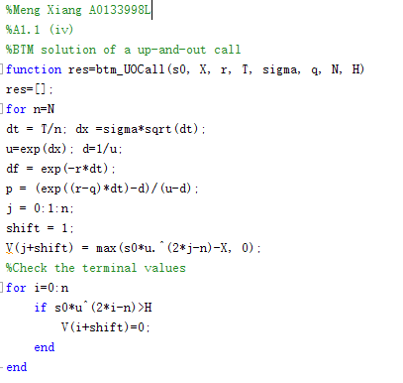

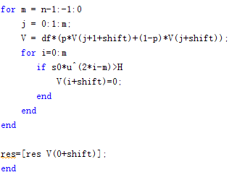

### Implementation:

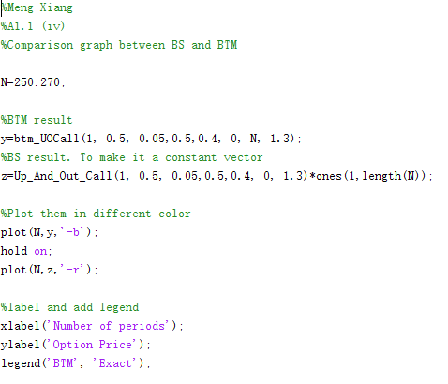

## A1.1(v):

## 

## A1.2(i):

### Function:

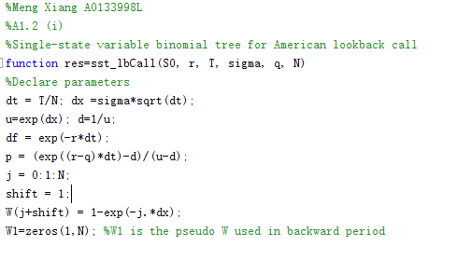

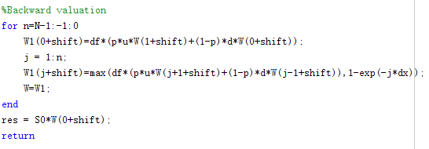

### Implementation:

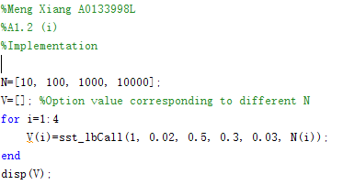

## A1.2(ii):

### Function:

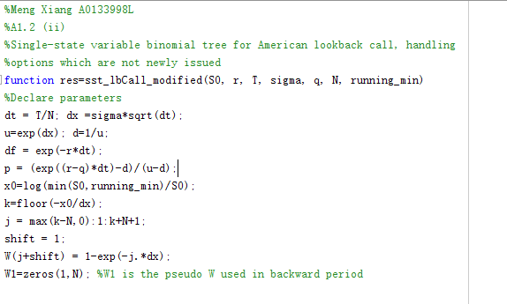

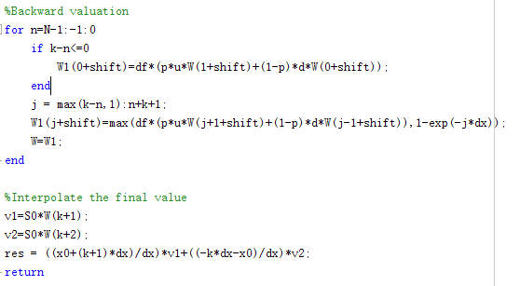

### Implementation:

